*TESTING*

Getting to testing took some time but we eventually got there, the first thing we decided to do was have a group meeting to decide on the best and most practical way for us to test a group. The group decided the best way to be fair would be to each to some of the code individually and later we could test it on the hardware as a group or individually. We would keep each other informed of any work done in the WhatsApp group we have and then updates would be posted to both the Trello and GitHub pages. The first test run we done was unsuccessful we used a breadboard several led lights, resistors and wires along with the Arduino Yun and grove kit. For the second test we decided to remove the breadboard and use the Arduino, grove kit, led socket and light sensor. This test went a little better the led worked and was responsive to the sensor, the led was in port 12 and the sensor was in A0 and there was no reading from the serial monitor. We decided we would like to make further improvements and add a clock to the project which required us to add some more code. This time our testing was not fully successful we got the clock working but the led light was constantly lit and unresponsive to the sensor. Back to the drawing board which required us to tweak the code slightly and once we tested it further it looked like we had it. We then noticed the clock would stop working once the led was plugged in. once again we made some small changes to the code changing the led IN to port six, leaving the clock in port twelve and the sensor in the A0 port. Success, the led was fully responsive to the sensor and the clock was reading in the correct time. When we opened the serial monitor, we could see the sensor was responsive to the different levels of light which it previously wasn’t which was what we had hoped to achieve. It took a little longer than expected to get there but it was a little expected at the same time, we kept chipping away at it as a team and got the desired result in the end.

Project two

The challenge of testing this time was somewhat different as Aaron had the smart bulb and we were trying to light it from a different location. To overcome the challenge of testing Aaron would turn on his webcam as we ran the code and we could see the effects happen if any. For testing in project two Paul had sourced the code need for the smart bulb and posted it on GitHub. Paul, Martin, Aaron and I individually worked on trying to get the code to work but to no success. We then scheduled a group meeting where we met on Microsoft teams and made several attempts to get the smart bulb working using the Arduino but no success again. We had the lcd in digital port two and the light sensor in analogue three, but something was wrong. We continued working on it in the meeting and Paul then altered some of his code and ran the code while asking Aaron if the light was lit and finally it was. We then scheduled another meeting on Microsoft teams this time to test the bulb with the code while using the light sensor. As we were testing, we had some difficulty with the sensor as the light was not fully responsive. It was late that night so we decided we would postpone the testing until the next day. The next day we gave the testing another go. This time we changed the lcd screen into digital port twelve C and put the light sensor into analogue port A three. We also brought down the delay time from one thousand to eight hundred. This time when we ran the code we could see through Aaron’s camera that the light had lit up red , this was a problem as we also needed it to light up the standard yellow depending on the level of light but this was not happening. We went back and adjusted the command on iffft the so the light would be the standard yellow or change to red depending on the level of light the sensor was reading in. when we went back to try this out it worked the light was responsive to the sensor. The light was coming on when the sensor was covered and going off when uncovered it was also reading in the light levels from the sensor as we previously had implemented in project one. The light was red when testing during the day and the standard yellow when we tested later that night. This is what we set out to achieve. We then took a video of some further testing we done and implemented one of the videos into our presentation when we were happy with both the testing and the video we had made. As a group we feel testing this time was more inclusive as we needed each other there to test the project. In project one we could test the led and sensor as we had all the equipment in one place but with the bulb being in a different location, we had to rely on each other to get the testing done. Whether this be testing the new rest API triggers we had implemented into our code it was being done now solely over the internet which was a change. Thankfully we got our testing complete with the new API and light sensor being responsive so we were ready to start preparing for the presentation.

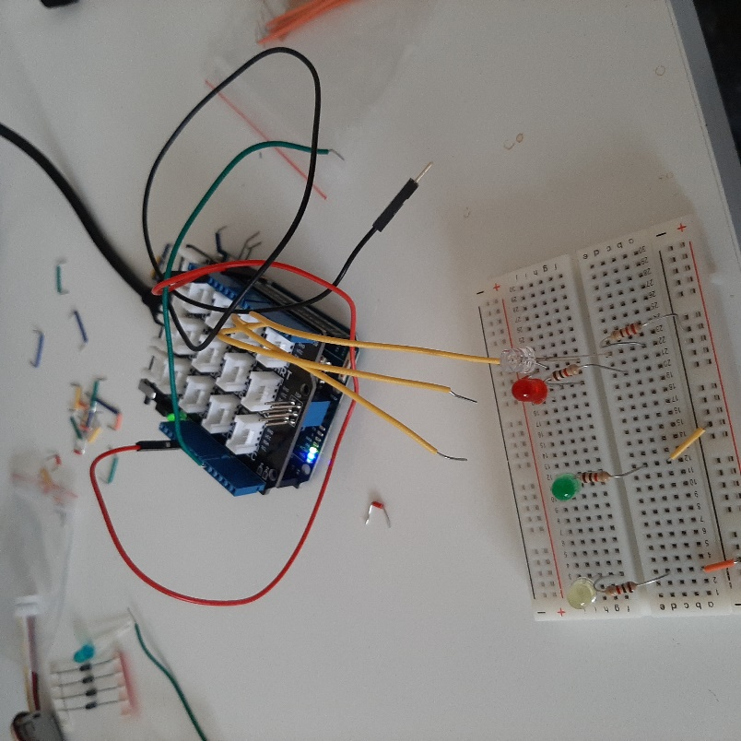

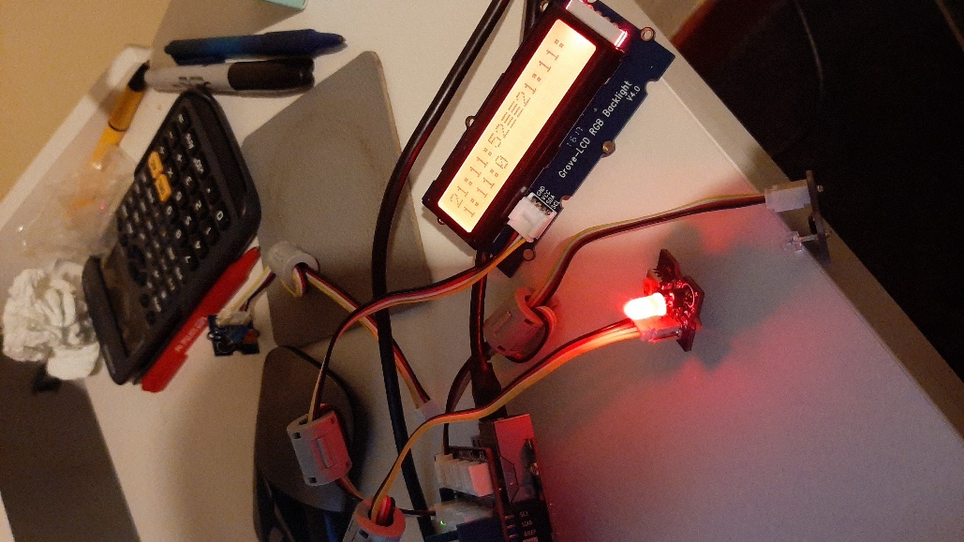

2nd test partial success clock works but prints more than once and led is lit constantly

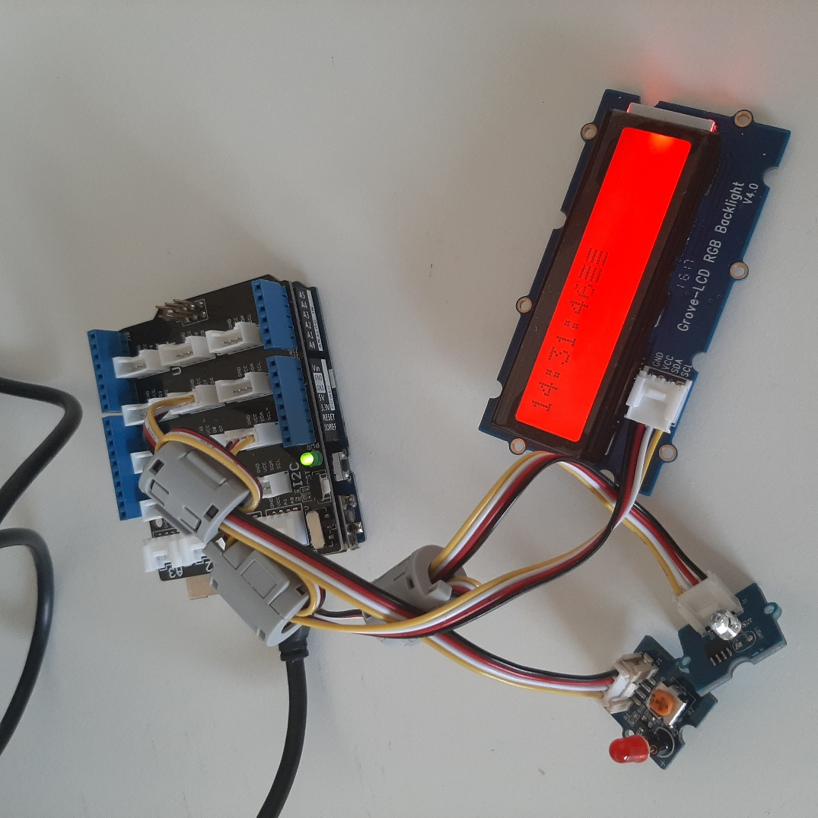

Final project clock working and responsive to light sensor.